ONLINE 5- ENGLISH 8- UNIT 9: PASSIVE
A. REVISION
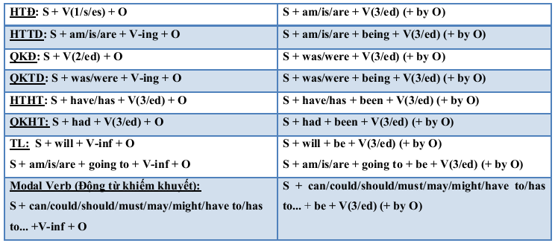

B. PRACTICE
I. ACTIVE OR PASIVE? (A/P)
1. I drink coffee everyday
2. A letter was written by Ann yesterday morning.
3. Music is being listened to by Lan at the moment.
4. Ann was writing a letter yesterday morning.
5. We have hired this car since yesterday
6. Ann is going to work this tree.
7. You should type this term paper.
8. That question can be answer by this boy.
9. Y our house will be painted white by my father tomorrow.
II. Choose the best answer
1. My classroom ----------- every day.
A. cleans B. cleaned C. is cleaned D. was cleaned
2. I still can’t believe it! My bicycle ----------- last night.
A. was stolen B. was stealing C. stolen D. stole
3. More than 50 films --------------- in HCMC since June.
A. were shown B. had been shown C. have been shown D. have shown
4. Bill ………………….Ann to the party tomorrow.
A. will be invited B. will invite C. have invited D. have been invited.
5. A new hospital ………………….in this area next year.
A. are going to be built B. builds C. is going to be built D. is going to build
6. Mike …………………. what’s going on in his English class.
A. can’t understand B. can’t be understoodC. could understand D. has been understood
7. Our test papers ………………….by our teachers now.
A. are marking B. are being marked C. will mark D. will be marked
8. When you are at school, your uniform …………………. at all times.
A. wears B. is wear C. is worn D. is wearing
III. Rewrite these following sentences in the passive.
1. A mechanic will service our car tomorrow morning.
=>
2. Dr. Peterson examined me at the surgery yesterday.
=>……………………………………………………………
3. People drink a great deal of tea in England.
=>………………………………………………………………….
4. People speak English all over the world.
=>…………………………………………………………………
5. He can’t answer these questions.
=>………………………
6. Mary has operated Tom since 10 o’clock.
=>……………………………………………………………………
7. Nobody swept this street last week.
=> ………………………………………….……………..
IV. Choose the best sentence
1. Some body cleans the room every day.
a. The room every day is cleaned. b. The room is every day cleaned.
c. The room is cleaned every day. d. The room is cleaned by somebody every day.
2. They cancelled all flights because of fog.
a. All flights because of fog were cancelled.
b. All flights were cancelled because of fog.
c. All flights were because of fog cancelled.
d. All flights were cancelled by them because of fog.
3. People don't use this road very often.
a. This road is not used very often. b. Not very often this road is not used.
c. This road very often is not used. d. This road not very often is used.
4. Somebody accused me of stealing money.
a. I was accused by somebody of stealing money.
b. I was accused of stealing money.
c. I was accused of stealing money by somebody.
d. I was accused stealing money.

